#finding top 10 highest revenue generating products

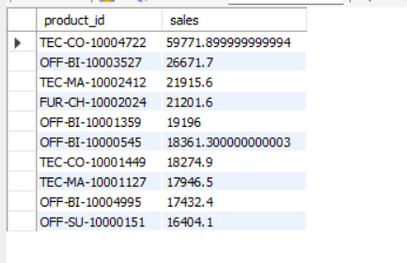

#finding top 5 highest selling products in each region

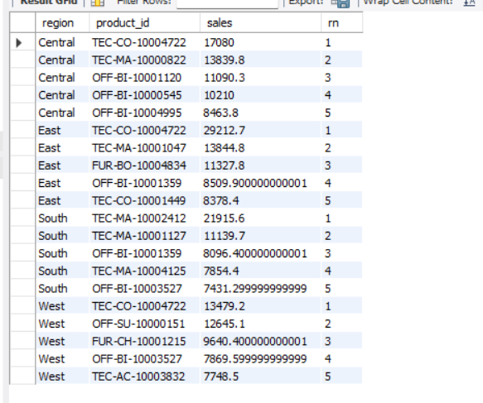

#finding month over month growth comparison for 2022 and 2023 sales eg : jan 2022 vs jan 2023

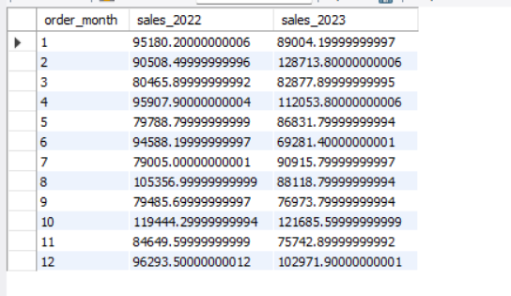

#for each category which month has the highest sales

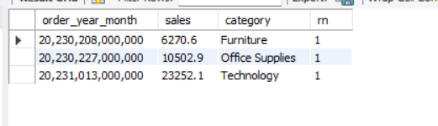

#which sub-category has the highest growth by profit in 2023 compare to 2022

